**User Stories**

# Registration

|  |  |
| --- | --- |
| User story | As a user I want to register to the IPN network so that I can use the network to transfer instantly |
| Acceptance criteria | * User should get a unique IPA * User should have a valid account * The user bank should be registered on the IPN network * User credentials are valid |

# Send Transaction

## Bank account to IPA

|  |  |
| --- | --- |
| User story | As a user want to send money instantly to anther IPA |
| Acceptance criteria | * Sender and receiver users should have an existed IPA * The bank will validate the atm-pin * Complete the transaction process * Users will notify by the transaction status (success or fail) * Log the transaction |

## Bank account to Wallet (phone number)

|  |  |
| --- | --- |
| User story | As a user want to send money instantly to anther Wallet |
| Acceptance criteria | * Sender user should have an existed IPA * Receiver should a wallet * Check if the wallet bank is registered * The bank will validate the atm-pin * Complete the transaction process * Users will notify by the transaction status (success or fail) * Log the transaction |

## Bank account to IBAN/account number

|  |  |
| --- | --- |
| User story | As a user want to send money instantly to anther IBAN/account number |
| Acceptance criteria | * Sender user should have an existed IPA * Receiver should a bank account * Check if the receiver bank is registered * The bank will validate the atm-pin * Complete the transaction process * Users will notify by the transaction status (success or fail) * Log the transaction |

# Add Account

|  |  |
| --- | --- |
| User story | As a user want to add account so that I can manage my accounts in one place |
| Acceptance criteria | * User should have a valid bank account * User atm-pin is valid * The user bank should be registered on the IPN network * User should have a valid IPA * Assign the user account to its IPA |

# Logs

|  |  |
| --- | --- |
| User story | As a CBE I want to be informed by the daily transactions from the tech provider |
| Acceptance criteria | * The tech provider should log all transactions in its database * The tech provider should inform the CBE with the transactions daily |

# Get the registered banks

|  |  |
| --- | --- |
| User story | As a tech-hub pay (tech provider) I want get a list of registered banks on the network to communicate with them |
| Acceptance criteria | * The CBE have the last update list of registered banks on the network * Tech-hub pay should request list of registered banks on the network from the CBE * The CBE provide the Tech-Hub Pay with the banks list and the new registered banks address |

**Send Money and Add Account**

**Client APIs**

|  |  |  |  |  |  |  |
| --- | --- | --- | --- | --- | --- | --- |
| NO. | Name | endpoint | Request | Response success | Response failed | Note |
| Registration | | | | | | |
| 1 | Registration | /register | ipa  bank-id  card-number  atm-pin  ipa-pin | Status(success | message (with the reason) | The client will provide and send the following information to the Tech provider (Tech-Hub Pay):  • The new user IPA  • Bank id  • Card number  • ATM PIN  • IPA-PIN (security wise to use it later in transactions)  Tech-Hub Pay will receive this information and will perform the following operation:  • Validate the new IPA and make sure that this new IPA is unique  • Validate that the Bank is registered in the IPN network (the registered banks will be provided by the CBE)  • Will generate a new unique account key to refer to the new added the bank account (it will be saved on the bank for later communication). |

|  |  |  |  |  |  |  |
| --- | --- | --- | --- | --- | --- | --- |
| NO. | Name | endpoint | Request | Response success | Response failed | Note |
| Send money | | | | | | |
| 1 | Request send money | /validate_atm_pin | bank-id | url | message (if the bank id not exist in the IPN network) | Client sends this request with bankId and we respond by the bank url that validate user account atm-pin. |
| 2 | Validate user account | /validate_receiver_account | bank-id | url | message (if the bank id not exist in the IPN network) except ipa | Client sends this request with bankId and we respond by the bank url that validate if receiver account is valid. |
| 3 | Transaction | /transaction | receiverBankId  amount  clientID  receiverAccountType  senderGeneratedAccount  receiverAccount | transactionId  transactionStatus | message (with the reason) | The client send this information and we will send this information to the issuer bank and save the transaction in the database until the bank response.  And we well tell the client that the transaction status is processing  ⚠️the client listens to a topic to know if the transaction status is completed or not |

|  |  |  |  |  |  |  |
| --- | --- | --- | --- | --- | --- | --- |
| NO. | Name | endpoint | Request | Response success | Response failed | Note |
| Add account | | | | | | |
| 4 | Request add account | /request_add_account | Ipa  bank-id | key  url | Message (with the reason) | Client sends ipa and bankId and we validate the ipa and bankid and generate the account key and we respond with the generated key and bank url. |
| 5 | Add account | /add_account | status  account-key | message (success) | message (fail) | The client send the status from the bank and the account key and we make the account key active if the status true otherwise we delete the temporary account key. |
| Others | | | | | | |
| 7 | Get registered banks | /getbanks | clientId | [List of banks] |  |  |
|  | Logs | /gettransactions |  | [List of transaction] |  |  |

**Database**

# Tech Hub Pay

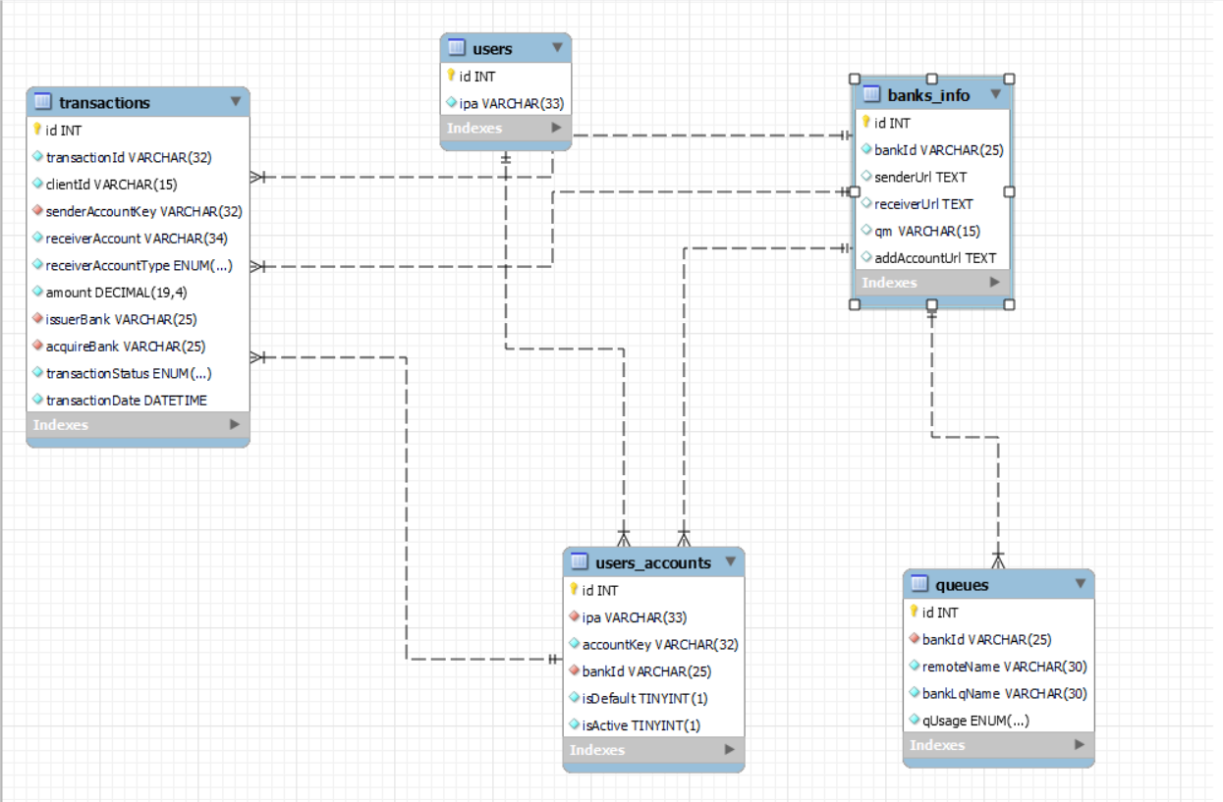

**⚠️remote Queue Name = bankId.usage.out (ex: bankOne.register.out)**

# Bank

